The Effects of Gentrification
Gentrification is a controversial and continuous process that has been occurring in historically disenfranchised neighborhoods in Chicago since the early 1950s-1970s as a result of urban renewal and white flight (Bentacur 388). Neighborhoods in Chicago such as Pilsen, Rogers park, Humboldt park, Uptown, and Bronzeville are all communities that have or are currently undergoing this process. Although gentrification in the past is a different process now, contemporary research has now been providing policy makers and scholars knowledge on the benefits and consequences of this process. However, a continuous debate surrounding this issue is whether gentrification is a process of supply and demand in regarding to housing in developing neighborhoods or it is an intentional displacement of people of color in order to bring an influx of White middle class population. The reality is that gentrification is a result of both economic and racial factors. However, to speak of gentrification, one must take into the consideration race and the effects that it has on its community and residents. Gentrification is not just a displacement of low income residents, but it is also a removal of a community’s history and culture that is transformed to serve newcomers, which, consequently, removes the services that helped sustain and progress of long term minority residents.
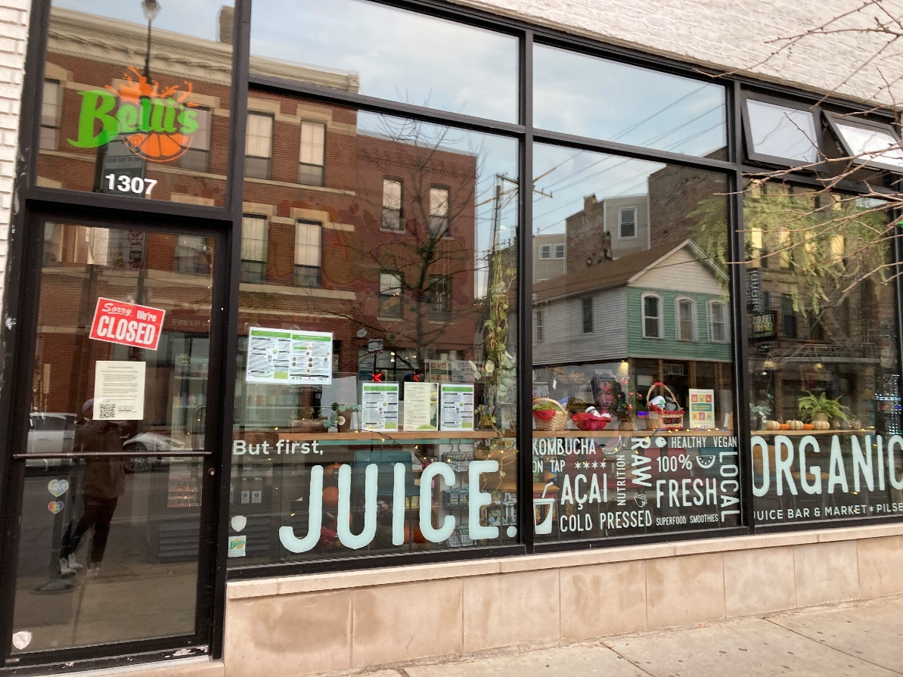

There are various driving forces to gentrification and research shows that this drive is led by educated millennials between the age of 20-30 moving to the central city in large municipalities. (Hyra 169). Research also shows that in movers are “wealthier, whiter, and of higher educational attainment that incumbent residents” (Zuk et all 37).They are drawn to these areas because of “service amenities, such as third-wave coffee shops, craft-beer gardens, and bike shares” (170 Hyra). Moreover, many choose to move into these areas due to their desire to be cool by living in areas that appear to be edgy or hip (Hyra 170).
The image presented located in the Pilsen community Chicago illustrates the amenities that interest the migrating population. Pilsen is known as a predominately Hispanic community with a rich cultural history. It is viewed by many as a “cool” urban center in which there are many services such as bars, restaurants, and coffee shops. However, although there are services that are Hispanic owned, there are also services that are not built for the Hispanic community but are instead tailored to newcomers and outsiders. This is problematic because “Gentrification is a claim to space. This event showcased the easy sense of ownership that gentrifiers bring to a neighborhood that has been contested space for decades, with no awareness of those struggles and the history of the people who fought them” (Curran 1725).

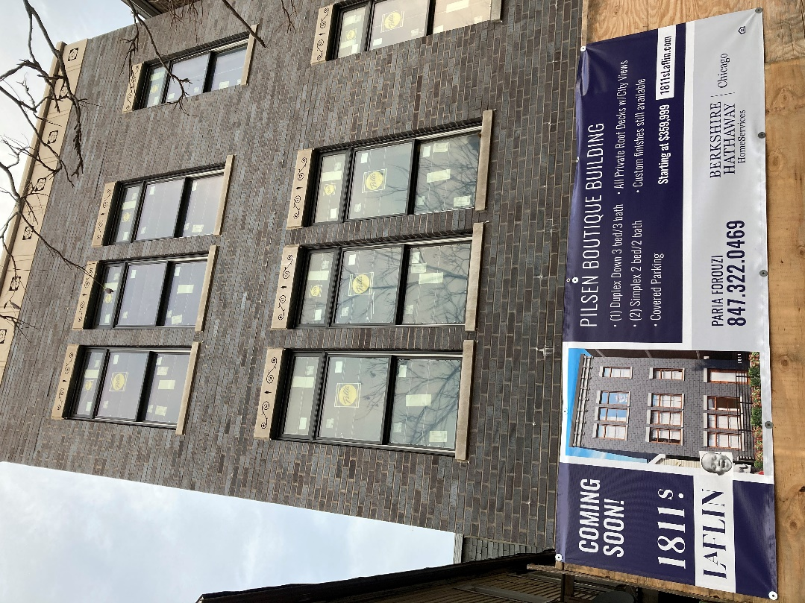
Gentrification occurs in areas where there are tight housing markets, rapid job growth, devaluated central neighborhoods, a rent gap, city amenities, tax incentives,and city policies in favor, but ultimately operates as “a marketdefining process” (Mumm 105) Moreover, another driving factor to gentrification are cheap credit and low interest rates that help “facilitate the private market production of luxury apartments in low-income neighborhoods” (Hyra 171). Historically, these conditions allowed investors to target communities and make development plans without taking into consideration how these developments would affect the residents. Moreover, the desire to create new housing units is not a result of lack of housing, rather it is formulated through the incentive for investors to create markets wherever possible (Mumm 105). This is problematic because the cost of these expensive housing units is artificially fabricated since they do not reflect the actual cost of living in these areas.
The image of the housing unit is in Pilsen. As previously mentioned, Pilsen is a Hispanic community, and it is composed of a working class. The fact that the building is at the cost of 360,000$ illustrates that it was not built for these people. It is these drastic prices that drives gentrification by preventing affordable housing and welcoming outsiders into these communities. In addition, housing and rent appreciation leads to the displacement of these population because they cannot afford to live in their community anymore(Atuesta and Hewings 43) Furthermore, these buildings were not created to host families which is a major contrast to what housing in Pilsen was. “For generations, the housing stock of Pilsen helped to stabilize immigrant working-class families by providing opportunities for both secure housing tenure and income. An affordable single-family home allowed extended families to live together and thus save money on housing while strengthening family ties and social networks. (Curran 1721)
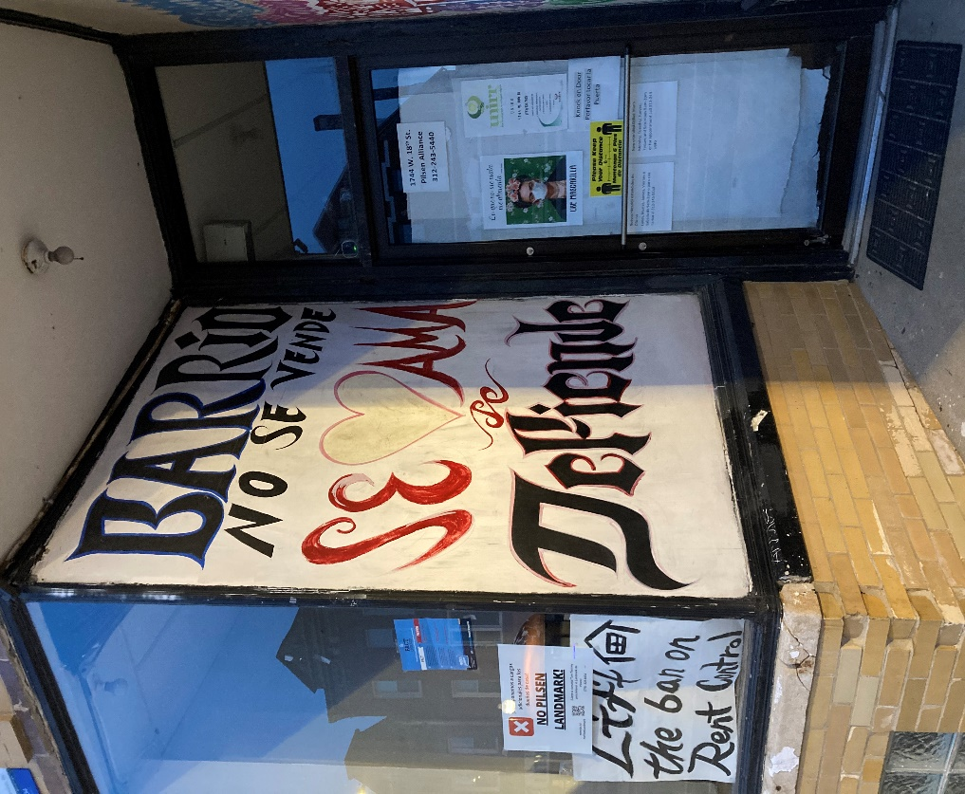
The justification for gentrification is that communities are presented as being “broken” and in need of fixing by the middle class (Curran 1714). This undermines the work of community organizers, residents, and others in attempt to resolve the issues within their neighborhood assisting in reducing violence and by providing services that improve the quality of life for its residence (Mumm 112). Moreover, newcomers will view long term residents as problematic or will have certain stigmas towards them. They will often use “coded language calling for the removal of “loiterers” (Mumm 112). In addition, initiatives benefiting Latino or Latino residents for community improvement such as resources, building institutions and affordable housing are also opposed by newcomers since they express fear towards these groups of people. (Mumm 112).
This image is located in a shop at Pilsen. It states that “the neighborhood is not to be sold, it should be loved and cared for” and reinforces the notion that the community of Pilsen rejections gentrification. It is a testament that people in this community did not need gentrification to “fix” the community and that the act itself is injustice. The people within this community truly care about bringing power to the people and aiding one another which has been proven by the community’s resistance to this process and the services and organizations that were established to meet the needs of the residents.
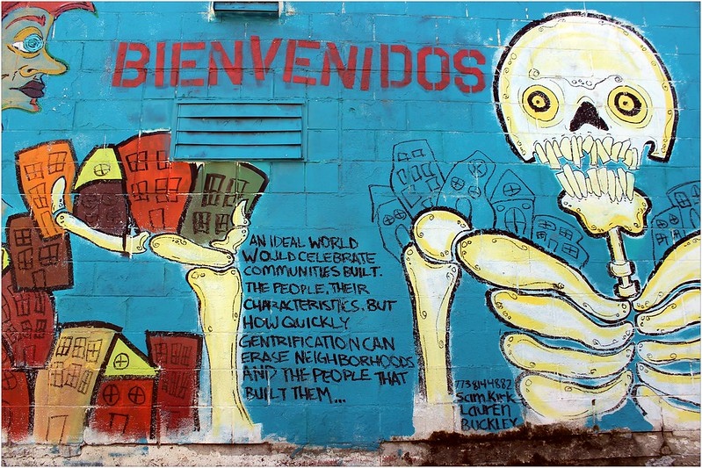

Gentrification is more than just displacement, it is “about the loss of, public space cultural capital and social networks job opportunities and commercial landscapes and the ability to participate in neighbourhood processes” (Curran 1712-1713). When newcomers establish their own presence in the neighborhood through organizing, this furthers the loss of identity. It shifts the political identity of a community since upper-income people dominate the political landscape which results in a loss of minority political representation (Hya 171). This results in newcomers establishing amenities and services that tailor to their vision of community improvement which, consequently, changes the norms and preferences that once dominated the neighborhood (Hya 171). This outcome is detrimental since the loss of these services, public spaces, and amenities results in a feeling of deprivation for long term residents especially those who benefited the most from these local services such as “senior citizens, women and children, and caretakers and recent immigrants” (Curran 1713-1714) . This makes long term residence feel as if they no longer belong there and it is just as distressing as physical relocation.
The mural located in Pilsen perfectly exemplify how a community’s history and identity is essentially robbed from its residents. The gentrification process truly undermines the persistent work of grass root initiatives aimed at creating a safer and prosperous community at Pilsen. It is as if the people of the community were incapable of enjoying the fruits of their labor because they were eventually displaced.

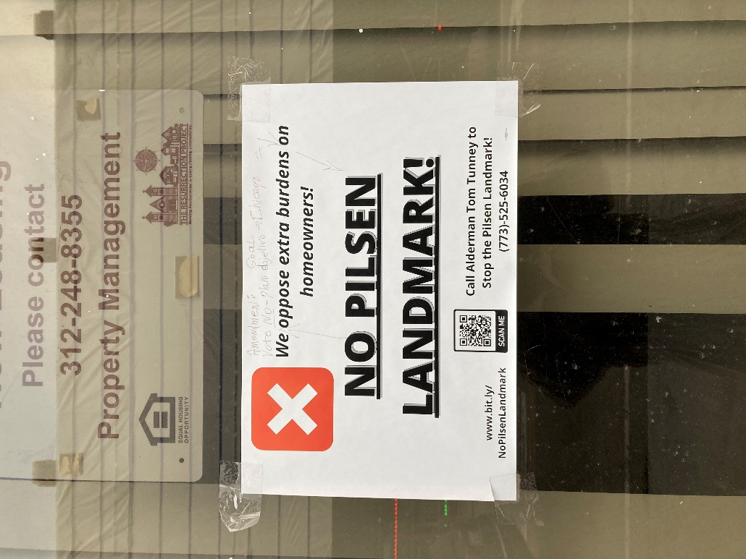

Despite bureaucrats, policymakers, and developer’s attempt to gentrify neighborhoods, they have faced resistance from communities. For example, “Pilsen’s strong Mexican identity as a powerful tool in the ‘save community’ discourse at play in the fight against gentrification in Pilsen. Its Mexican-ness helped give it the reputation of a ‘ready-to-rumble neighbourhood’ where developers feared that virulent street tactics, such as harassment of gentrifiers, would make development projects risky” (Curran 1715). This strong community resistance helped slow down the process of gentrification, but it has not stopped the process. Many people have been displaced as a result of gentrification and “those most vulnerable to displacement end up in much poorer neighbourhoods” (Curran 1714)
This image was found in Pilsen and asks the community to be civically engaged by contacting the alderman in order to turn over the decision to make Pilsen a landmark. If this initiative passes, then more people will be displaced because of higher taxes for working class homeowners, and it will contribute the process of gentrifying the neighborhood. Moreover, this image also highlights that gentrification is an ongoing process since this neighborhood was undergoing development for years. “Gentrification is a long, drawn out process which entails a series of displacements and resistance strategies that shape how it takes place in particular urban neighbourhoods”(Curran 1712).
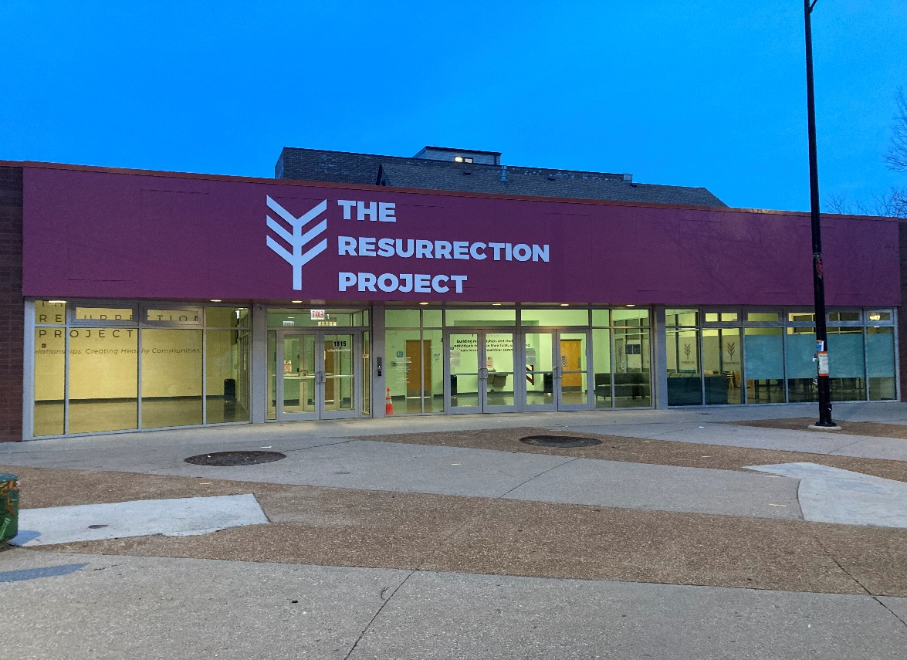

Pilsen illustrates the power of organization and grass roots movements. In this community, “Groups have clustered together forming networks, non-market mechanisms, institutions and platforms of mutual support and bargaining, turning neighbourhoods, industries and institutions into ethnic powerhouses” (Betancur 387). However, gentrification also played a major role in deteriorating these efforts and often caused a divide within institutions and the community. In an interview between Uptown, West Town, and Pilsen residents, they all agreed that gentrification undermined community work and had split people between supporters and opponents, old-timers and newcomers (Betancur 396). Ultimately, the harm caused by gentrification weakened grassroot institutions, divided residents and non-profits, ran some non-profits out of business, and transformed some institutions into agencies that were less interested in providing services and more focused on long term goals (Betancur 398-399).The resurrection project has become an extended agency found in several communities in Chicago. Although, it does serve its role in assisting with community needs, they have shifted their focus to preserve their organization and to achieve organizational goals.

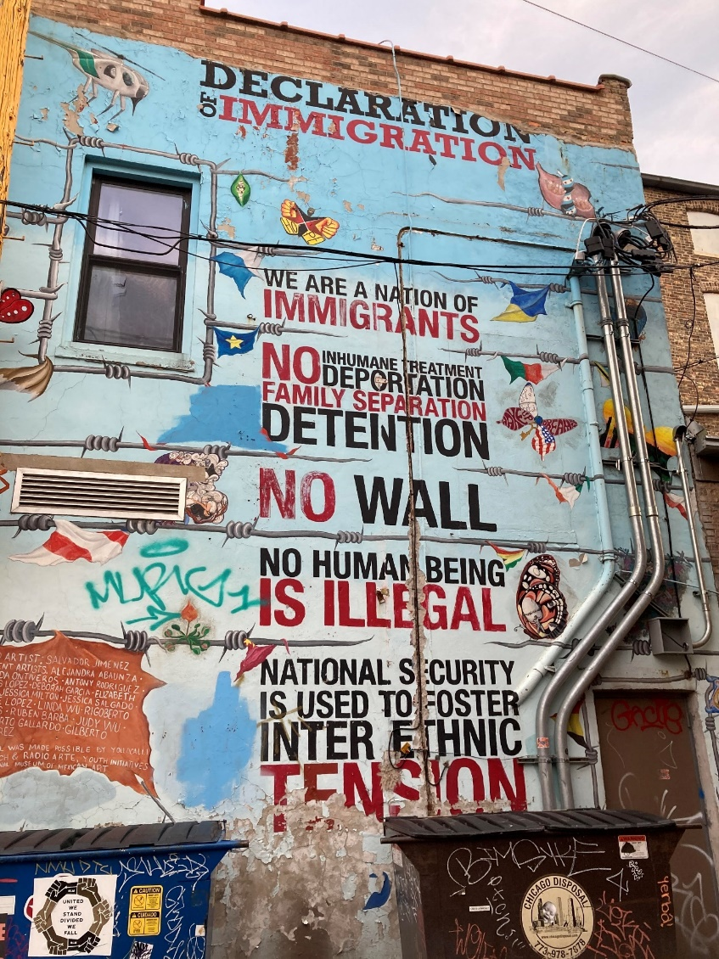
The rhetoric of gentrification as urban development is a tactic to justify and promote this action. As previously mentioned, these communities are viewed as being broken. Gentrification, thus, is used and is viewed as a tool of cleansing that is beneficial to the city (Wilson and Grammeros 297). This is especially the case in the community of Humboldt park since Puerto Rican people were viewed as being the root cause for their community’s problems. Instead of focusing on the fundamental cause of the issue such as poverty, the city used the narrative that “grimy barrios, impulsive Puerto Ricans, wild and wooly youth, roaming and territorially obsessed gangs, and morally ungrounded adults and families” were the driving factors (Wilson and Grammeros 309-310) Furthermore, the ideology of self-determination and meritocracy are used by gentrifiers to blame poor people for their poverty (Mumm 105). When gentrifiers came into Humboldt park, they described prior residence as gangs, low class, ill mannered and low cultured. They described their displacement and community deterioration because of their behavior and values (Betancur 392). The reasoning to displace people of color is predicated on racist notions associated to them. Nevertheless, despite these stigmas, white people often find themselves not being victims of violence when moving into these neighborhoods. This white privilege enables them to create white markets in these communities which furthers the action of gentrification and displacement. (Mumm 113)
The mural is located at Pilsen, and it truly depicts serves as a reminder that the community derives from an immigrant background. Moreover, it also may prove a role to reinforce this information to the newcomers in the neighborhood. In fact, this image may serve as a counter narrative to the stigmas surrounding immigrants. It is not the nature of the people that create racist stigmas, but instead it is the separation and classification of these people that causes this divide.

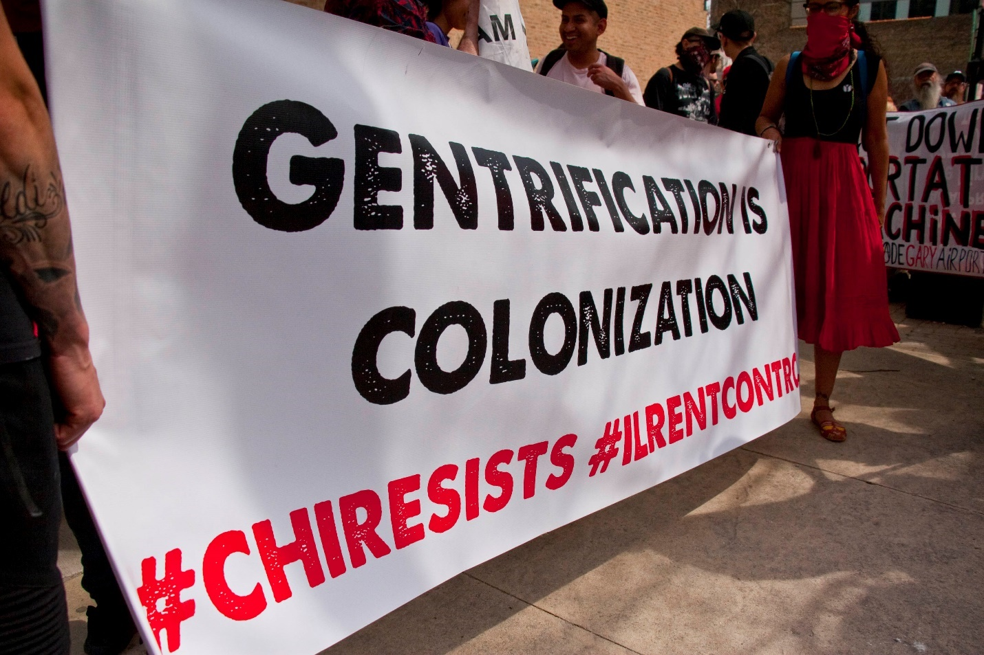
Ultimately, gentrification is a form of racism. It is best described as:
“Gentrification in a historically racially segregated city like Chicago represents a racial fix, a
way for capital investors and property buyers to assign value that is artificially inflated by constant reference to whiteness in relation to people of color. Here in Chicago, that process depends heavily on cultivating, convincing, and enabling a white newcomer market that their reclamation and transformation of historical and cultural centers of black, Mexican, and Puerto
Rican life in Chicago is possible, inevitable, and even ostensibly benevolent”. (Mumm 114)
Mumm’s statement resonates with the statement that gentrification is colonization. The displacement of poor people of color, the removal of a community’s identity, and the sociological and political transformation of that community representing the interest of the white middle class are the consequences of gentrification. The disregarding of racism in the discussion of gentrification is criminal as it justifies the act. White privilege and white power structures dominate the American landscape in all aspects. The historical political structures that fostered inequality are still felt today and racial capitalism, which is the process of deriving social and economic value from racial subordination (Mumm 103) is best manifested through the act of gentrification.

Works Cited
Atuesta, Laura H, and Geoffrey J.D Hewings. “Housing Appreciation Patterns in Low-Income Neighborhoods: Exploring Gentrification in Chicago.” Journal of housing economics 44 (2019): 35–47. Web.
Using data from Chicago, this paper analyzes different housing appreciation patterns from 1983 to 2005 depending on the initial level of income of the neighborhoods where these properties are located. Findings suggest that appreciation patterns of low-income neighborhoods are different than those of high-income neighborhoods. Moreover, appreciation of housing prices in low-income neighborhoods that have experienced gentrification is different than in other low-income neighborhoods not gentrified. To analyze this issue further, we compare the behavior of housing prices in neighborhoods experiencing different stages of gentrification with housing prices in low-income neighborhoods that have not been gentrified. Housing price appreciation is only observed in neighborhoods gentrified that had low levels of income when gentrification was measured. One interpretation of these findings is that housing prices appreciate in neighborhoods experiencing early stages of gentrification, but not in neighborhoods that have been gentrified for longer periods of time. These results could suggest that gentrification may cause displacement pressures in the early stages, but prices are stabilized in neighborhoods being gentrified for some time, reducing the probability of displacement of the low-income population

Betancur, John. “Gentrification and Community Fabric in Chicago.” Urban Studies., vol. 48, no. 2, Carfax International Publishers, Feb. 2011, pp. 383–406, doi:10.1177/0042098009360680.
Critical authors of gentrification point to its deleterious impacts on displaced residents. Research on the nature or actual forms of impacts has not advanced much, however. This paper attempts to specify impacts on low-income racial/ethnic groups (Latinos in particular) in five Chicago neighbourhoods, with a particular focus on neighbourhood-based fabrics of support and advancement. Limited in their mobility and exchange value resources, lower-income groups depend on such fabrics far more than do the higher income. In fact, they have fewer choices and are most vulnerable to place-based shifts. The case seems especially challenging for minorities who, like European immigrants before them, depend largely on place-based platforms/social fabrics but, unlike them, confront the added factors of race and urban restructuring.

Curran, Winifred. “‘Mexicans Love Red’ and Other Gentrification Myths: Displacements and Contestations in the Gentrification of Pilsen, Chicago, USA.” Urban Studies, vol. 55, no. 8, June 2018, pp. 1711–1728, doi:10.1177/0042098017736503.
This article uses experiences from a decade-long community-based research project in the Pilsen neighborhood of Chicago, a Mexican-American neighborhood whose residents are both experiencing and resisting gentrification, to show how displacements and contestations evolve in conversation with each other in an iterative process we could call ‘actually existing’ gentrifications. I analyze a series of ‘moments’ in 13 years of research in Pilsen to illustrate the constantly shifting terrain of gentrification politics, covering not just housing affordability, but the nature of identity, democracy and belonging. As communities develop resistance strategies to gentrification, so too do city planners, policy makers and developers adapt to these community strategies to reframe their vision of the community. In highlighting both the success of community resistance in mitigating some of the worst effects of gentrification and the co-optation of some of these same strategies in the reframing of gentrification, my goal is to show that gentrification is rarely ever done or complete but is continuously enacted and resisted, challenging the idea that gentrification is somehow inevitable.

Doering, Jan. “Us Versus Them: Race, Crime, and Gentrification in Chicago Neighborhoods.” Us versus Them, Oxford University Press, 2020, doi:10.1093/oso/9780190066574.001.0001.
The first chapter gives an overview of crime and gentrification in Rogers Park and Uptown. It explains why residents largely regarded efforts to tackle these interconnected problems as mutually exclusive. It also situates the local tensions about crime and gentrification in the broader historical and structural context of racial segregation and integration in the American city. In addition, the chapter introduces the book’s methodological approach, outlines its research questions, and develops its theoretical framework. Regarding the theoretical framework, the chapter introduces two simple concepts, “racial challenges” and “racial neutralizations,” which describe the contentious work of framing social phenomena as racially problematic or racially benign.

Hwang, Jackelyn, and Robert J. Sampson. “Divergent Pathways of Gentrification: Racial Inequality and the Social Order of Renewal in Chicago Neighborhoods.” American Sociological Review, vol. 79, no. 4, 2014, pp. 726–751. JSTOR, www.jstor.org/stable/43187561. Accessed 2 Oct. 2020.
Gentrification has inspired considerable debate, but direct examination of its uneven evolution across time and space is rare. We address this gap by developing a conceptual framework on the social pathways of gentrification and introducing a method of systematic social observation using Google Street View to detect visible cues of neighborhood change. We argue that a durable racial hierarchy governs residential selection and, in turn, gentrifying neighborhoods. Integrating census data, police records, prior street-level observations, community surveys, proximity to amenities, and city budget data on capital investments, we find that the pace of gentrification in Chicago from 2007 to 2009 was negatively associated with the concentration of blacks and Latinos in neighborhoods that either showed signs of gentrification or were adjacent and still disinvested in 1995. Racial composition has a threshold effect, however, attenuating gentrification when the share of blacks in a neighborhood is greater than 40 percent. Consistent with theories of neighborhood stigma, we also find that collective perceptions of disorder, which are higher in poor minority neighborhoods, deter gentrification, while observed disorder does not. These results help explain the reproduction of neighborhood racial inequality amid urban transformation.

Hyra, Derek. "Commentary: Causes and Consequences of Gentrification and the Future of Equitable Development Policy." Cityscape, vol. 18, no. 3, 2016, pp. 169-177. ProQuest, http://proxy.cc.uic.edu/login?url=https://www-proquest-com.proxy.cc.uic.edu/docview/
1856560391?accountid=14552.
[...]many 20- and 30-somethings seem to choose their residential location, in part, based on their desire to be cool by living in what is perceived to be edgy, hip urban areas (Hyra, in press; Ocejo, 2014; Parker, 2016), and we need investigations to account for these alternative gentrification causes. [...]credit continues to be cheap, with historically low interest rates, and these low rates are helping to facilitate the private market production of luxury apartments in low-income neighborhoods. [...]our gentrification models must grapple with both supply- and demand-side gentrification explanations to more fully grasp the comprehensive set of factors facilitating major central city demographic shifts and neighborhood change (Brown-Saracino, 2010)

Freeman, Lance M. “Commentary: 21st Century Gentrification.” Cityscape, vol. 18, no. 3, 2016, pp. 163–168. JSTOR, www.jstor.org/stable/26328278. Accessed 2 Oct. 2020.
The papers presented at the Research Symposium on Gentrification and Neighborhood Change, sponsored by the Federal Reserve Bank of Philadelphia and held in Philadelphia, Pennsylvania, on May 25, 2016, are indicative of a sea change in gentrification scholarship. In this commentary, I place the research presented at the research symposium and in the Symposium section of this issue of Cityscape into the context of earlier research on gentrification. In doing so, I aim to show how this scholarship complements our understanding of the process of gentrification and to also show how current efforts might be informed by understanding past scholarship

Mumm, Jesse. “The Racial Fix: White Currency in the Gentrification of Black and Latino Chicago.” Focaal 2017.79 (2017): 102–118. Web.
In Chicago, real estate value is fixed by race through the process of gentrification. I present findings from an ethnography of the black, Mexican, and Puerto Rican neighborhoods of the greater West Side. Gentrification here is a “racial fi x”: a consensus-building process to inflate value in a speculative market reliant on the historical legacies of racism. Th e white flight era devalued neighborhoods now facing speculation and hyperinflation as increased global investment, debt culture, and debt financing fuel the growth machine. Th e discourses of residents, randomized survey results, and a built environment scan show that property value corresponds more to white residence than material improvement. White people cultivate the currency of whiteness through gentrification to build social status, capital, and the city of their dreams.

Wilson, David, and Dennis Grammenos. “Gentrification, Discourse, and the Body: Chicago’s Humboldt Park.” Environment and Planning D: Society and Space, vol. 23, no. 2, Apr. 2005, pp. 295–312, doi:10.1068/d0203.
Gentrification today spreads and deepens in US cities. In this paper we examine the progentrification rhetoric and tactics confronted by the second largest Puerto Rican community in the United States, Chicago's Humboldt Park. Three points are documented in this current case. First, real-estate capital and the media now target and script Puerto Rican youth bodies to communicate a new gentrification-sanitizing theme: a disgust for `ghetto' morals and social order. Second, this coding of bodies involves a key process, taking readers to imaginary spaces in discourse. Third, possibilities to thwart gentrification exist but organizing strategies are ineffective in that they fail to confront the politics of youth bodying. The results shed light on one of the ascendant strategies of capital to restructure Spanish-speaking neighborhoods and a subset of them, Puerto Rican communities.

Zuk, Miriam, et al. “Gentrification, Displacement, and the Role of Public Investment.” Journal of Planning Literature, vol. 33, no. 1, Feb. 2018, pp. 31–44, doi:10.1177/0885412217716439.
Scholarly interest in the relationship between public investments and residential displacement dates back to the 1970s and the aftermath of displacement related to urban renewal. A new wave of scholarship examines the relationship of gentrification and displacement to public investment in transit infrastructure. Scholarship has generally conflated gentrification and displacement; however, this review argues for a clearer analytical distinction between the two. Although the displacement discussion in the United States began with the role of the public sector and now has returned to the same focus, it will be necessary to overcome methodological shortcomings to arrive at more definitive conclusions about the relationship.

